Westport Public Library  Arnold Berhard Plaza  McManus Meeting Room  Wednesday March 19th 2003  6PM  Bill McDonough Speaks on  the Greening of Schools | 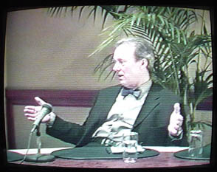

Documentary producer Frank Knize of Georgetown and co-producer Remy Chevalier of Weston interview green architect William McDonough at the National Association of Independent Schools conference held on February 27th in New York City.
Mr. McDonough is a graduate of Staples High School, class of 69. He is the author of the non-fiction bestseller "Cradle to Cradle" and has written the preface to "Big & Green; Toward a Sustainable Architecture in the 21st Century," the companion book to the Big & Green architectural exhibit currently being held at the National Museum in Washington DC.
Mr. Knize and Mr. Chevalier are producing a documentary on the greening of Staples High School. In the interest of the community, they have agreed to share the unedited portion of this 55 minutes interview with all concerned Westporters.
The producers hope to finish their documentary, with the working title: "The Greening of Staples High School," in time for a premiere showing at the Connecticut Department of Environmental Protection high performance schools conference scheduled for New Haven this June.
For more information on the production, go to www.greenburbs.com. Click into the solar section.

Contact: Remy Chevalier 203-227-2065

